The university of Azad Jammu and Kashmir ,Muzaffarabad

Student Name: Qurat Ul Ain Fatima
Roll No: 2024-SE-05
Course Title: Database Systems
Course Code: CS-2204
Lab Instructor: Awais Rathore
Department: Software Engineering

Lab#07
SQL Filters:
Introduction:
SQL filters are used to retrieve specific records from a database according to given conditions. In Part A, basic comparison and logical operators were used to filter employee records.
In Part B, more SQL filtering techniques are practiced. These include BETWEEN, IN, LIKE, IS NULL, ORDER BY, and LIMIT. These clauses and operators make it easier to search for records within a particular range, match specific values or patterns, identify missing data, sort results, and restrict the number of records displayed.
This experiment continues working with the Employee database and applies these filtering techniques to the employee records provided in the lab manual.

Objectives:
The objectives of this experiment are:
- To understand the use of the BETWEEN operator.
- To filter records within a specific range.
- To use the IN operator for matching multiple values.
- To understand pattern matching using the LIKE operator.
- To identify NULL values using IS NULL.
- To retrieve records containing or starting with specific characters.
- To sort records using ORDER BY.
- To sort records in ascending and descending order.
- To use LIMIT to restrict the number of records displayed.
- To practice different SQL filtering techniques on the Employee database.
. Software and Tools Required
The following software and tools are required:
- MySQL 8.x
- MySQL Workbench or MySQL Command Line Client
- Employee database used in the previous experiment
- Computer system

Database Setup:
The Employee database and its records were created before performing the filtering operations.
BETWEEN Operator:
The BETWEEN operator is used to select records whose values fall within a specified range.
It can be used with numeric values and dates. The range includes both the lower and upper values.
For example, it can be used to find employees whose salary is between two specified amounts.

IN Operator:
The IN operator is used when we want to compare a column with multiple possible values.
Instead of writing several OR conditions, IN allows multiple values to be specified together.
It can be useful when filtering employees who belong to selected cities or departments.

LIKE Operator:
The LIKE operator is used for pattern matching.
It allows records to be searched according to characters or patterns in a text field.
The commonly used wildcard characters are:
- % — represents zero or more characters.
- _ — represents a single character.
For example, LIKE can be used to find employee names that start with a particular letter, contain
a particular letter, or end with a particular combination of characters.

IS NULL:
NULL represents a missing or unknown value in a database.
The IS NULL condition is used to find records where a particular field does not contain a value.
In this experiment, it is used to find employees whose city information has not been recorded.
ORDER BY:
ORDER BY is used to arrange the retrieved records in a particular order.
The two main sorting directions are:
- ASC — ascending order
- DESC — descending order
Ascending order is normally used for arranging values from smaller to larger or names from A to Z. Descending order reverses the order.
LIMIT:
LIMIT is used to restrict the number of records returned by a query.
For example, it can be used to display only the highest-paid employees or the most recently hired employees when combined with an appropriate ORDER BY condition.

Procedure:
The following procedure was followed to complete Part B:
- I opened MySQL Workbench.
- I selected the database used for the SQL Filters experiment.
- I verified that the Employee table contained the required records.
- I applied the BETWEEN operator to filter values within a range.
- I used the IN operator to select records matching multiple values.
- I used the LIKE operator to search for specific text patterns.
- I used IS NULL to identify missing values.
- I used ORDER BY to arrange the retrieved records.
- I used LIMIT to display a specified number of records.
- I executed each task separately and checked the output.
- I captured screenshots of the query results for the lab record.

Practical Tasks Part B:
B1. Employees with Salary Between 75,000 and 100,000
Requirement:
Display employees whose salary is between 75,000 and 100,000, including both limits, and arrange the results in ascending order of salary.
Description:
This task demonstrates the use of the BETWEEN operator together with ORDER BY. The result should contain only employees whose salaries fall within the specified range.
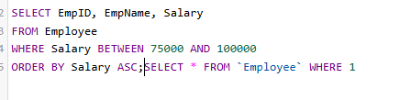
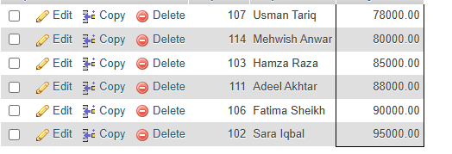
B2. Employees Hired Between January 2020 and December 2022
Requirement
Display employees who were hired between January 2020 and December 2022.
Description
This task demonstrates the use of BETWEEN with dates. It filters employees according to their hiring dates.
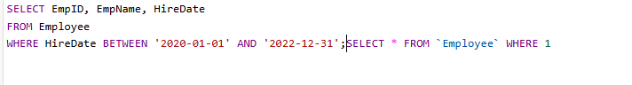
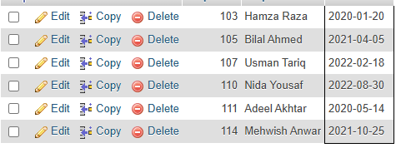
B3. Employees Whose Salary Is Not Between 80,000 and 100,000
Requirement
Display employees whose salary does not fall between 80,000 and 100,000.
Description
This task demonstrates how the NOT condition can be combined with a range condition to exclude a specific salary range.
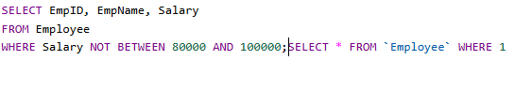
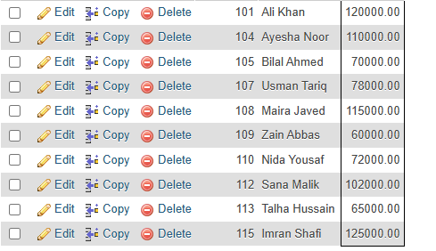
B4. Employees from Lahore or Islamabad
Requirement
Display employees who are from Lahore or Islamabad and sort the results first by city and then by salary in descending order.
Description
This task demonstrates filtering records using multiple city values and applying more than one sorting condition.
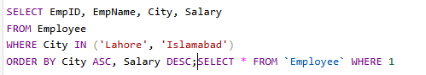
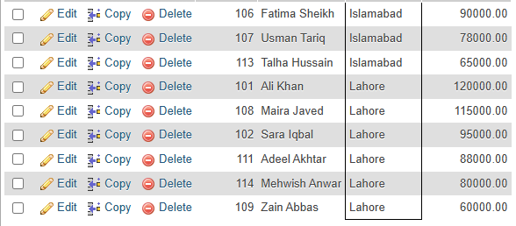
B5. Employees from Departments Other Than Engineering, Sales and HR
Requirement
Display employees who do not belong to the Engineering, Sales, or HR departments.
Description
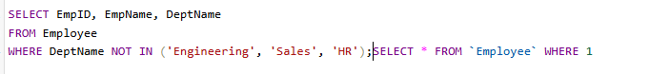
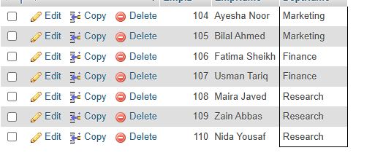
B6. Employees Whose Names Start with M
Requirement
Display employees whose names start with the letter M.
Description
This task demonstrates pattern matching using the LIKE operator. The pattern is used to identify names beginning with the specified character.
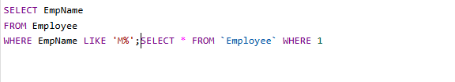
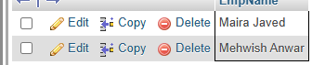
B7. Employees Whose Names Contain the Letter A
Requirement
Display employees whose names contain the letter A anywhere in the name.
Description
This task demonstrates the use of the LIKE operator for finding a character at any position within a name. The lab manual specifies that the search should be case-insensitive.
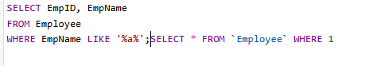
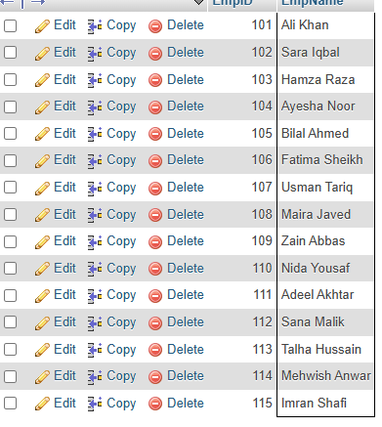
B8. Employees Whose Names End with "an"
Requirement
Display employees whose names end with "an".
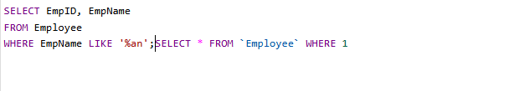
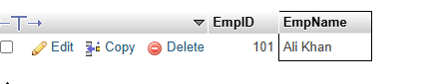
B9. Employees Whose Job Title Contains "Engineer"
Requirement
Display employees whose job title contains the word Engineer, but whose department is not Engineering.
Description
This task combines pattern matching with a department filtering condition. It demonstrates how different filtering conditions can be applied together.
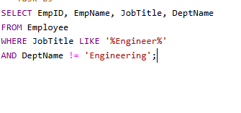

B10. Employees with No Recorded City
Requirement
Display employees whose city information has not been recorded.
Description
This task demonstrates the use of IS NULL to identify missing values in the City field.
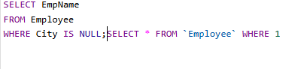
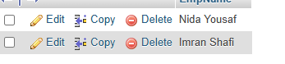
B11. Employees with a Recorded City
Requirement
Display employees who have a recorded city and sort the results alphabetically by city.
Description
This task demonstrates how NULL values can be excluded and how the remaining records can be sorted alphabetically.
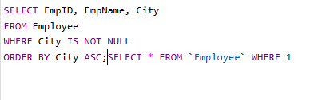
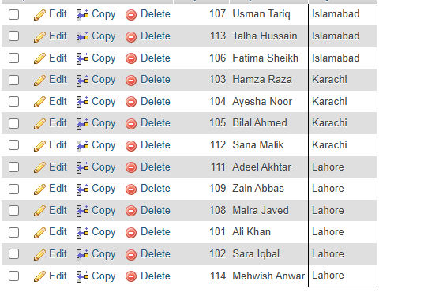
B12. Three Highest-Paid Employees
Requirement
Display the three highest-paid employees, showing their names and salaries.
Description
This task demonstrates the combined use of ORDER BY and LIMIT. The records are arranged according to salary, and only the required number of records is displayed.
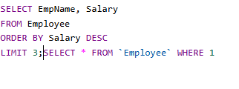
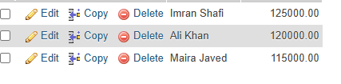
B13. Five Most Recently Hired Employees
Requirement
Display the five most recently hired employees.
Description
This task uses the hire date to arrange employees from the most recent hiring date and limits the result to five records.
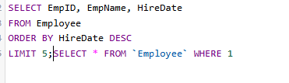
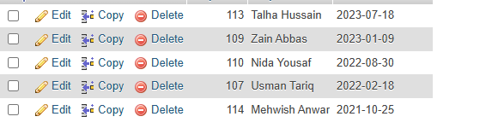
B14. Three Employees with the Lowest Salaries
Requirement
Display the bottom three salaries, starting with the lowest salary.
Description
This task demonstrates descending or ascending sorting according to the required result and the use of LIMIT to restrict the output to three employees.
[Insert Screenshot of B14 Query and Result Here]
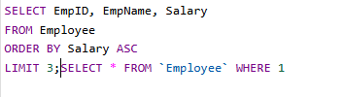
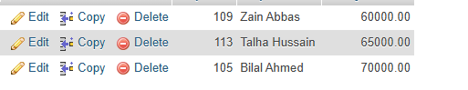
B15. Employees Sorted by Department and Hire Date
Requirement
Display all employees sorted by department in ascending order and then by hire date in ascending order.
Description
This task demonstrates multiple-column sorting. The department is considered first, followed by the employee's hire date.
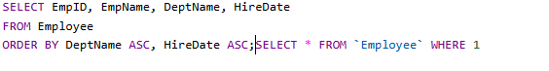
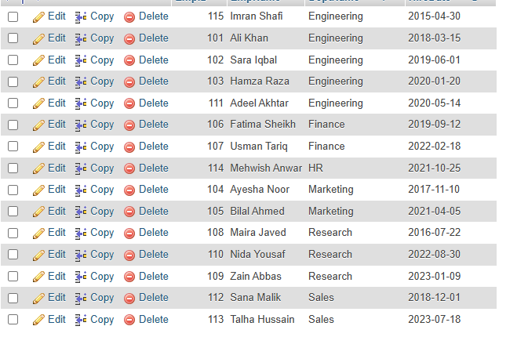

8. Results and Observations
After completing Part B, the required employee records were successfully filtered and organized using different SQL techniques.
The following observations were made:
- BETWEEN was useful for selecting records within a specific numeric or date range.
- • IN was useful for matching multiple specified values.
- • LIKE was useful for searching employee names and job titles according to patterns.
- • IS NULL was used to identify missing city information.
- • ORDER BY arranged the results in the required order.
- • LIMIT restricted the output to a specific number of records.
- • Multiple filtering and sorting conditions could be combined in a single query.
- • The results helped demonstrate how SQL can be used to retrieve specific information from a larger dataset.
- 9. Conclusion
- In this experiment, I practiced different SQL filtering techniques using the Employee database. I used BETWEEN, IN, LIKE, IS NULL, ORDER BY, and LIMIT to retrieve and organize employee records according to different requirements.
- The experiment helped me understand how SQL filters can be used to search for specific records, work with ranges and patterns, handle missing values, sort results, and limit the number of displayed records. These techniques are useful for retrieving meaningful information from databases efficiently.

